**Name: Nafinur Leo**

**Id: 20-42195-1**

**Course Name: Data Communication**

**Section: D**

**Lab Report Number: 07**

**Semester: 2021-2022 Fall**

**Submission Date: 22-11-2021**

**Lab Performance Task**

ID = AB-CDEFG-H

Here, my id is: 20-42195-1

A = 2, B = 0, C = 4, D = 2, E = 1, F = 9, G = 5, H = 1

Code:

clc

clear all

close all

F=9;

G=5;

fs = 4001;

t = 0:1/fs:1-1/fs;

am1 = F+2;

fm1 = (G+1);

mt1 = am1*cos(2*pi*fm1*t);

am2 = (F+5);

fm2 = (G+2);

mt2 = am2*cos(2*pi*fm2*t);

am3 = (F+8);

fm3 = (G+3);

mt3 = am3*cos(2*pi*fm3*t);

am4 = (F+11);

fm4 = (G+4);

mt4 = am4*cos(2*pi*fm4*t);

Cmt1 = 1;

fc1 = 56;

c1 = Cmt1*cos(2*pi*fc1*t);

Cmt2 = 1;

fc2 = 132;

c2 = Cmt2*cos(2*pi*fc2*t);

Cmt3 = 1;

fc3 = 176;

c3 = Cmt3*cos(2*pi*fc3*t);

Cmt4 = 1;

fc4 = 240;

c4 = Cmt4*cos(2*pi*fc4*t);

x = (mt1).*c1+(mt2).*c2+(mt3).*c3+(mt4).*c4;

figure

subplot(4,1,1)

plot(t,mt1)

xlabel('time')

ylabel('amplitude')

title('Message signal 1 in time domain')

ylim([-am1 am1])

subplot(4,1,2)

plot(t,mt2)

xlabel('time')

ylabel('amplitude')

title('Message signal 2 in time domain')

ylim([-am2 am2])

subplot(4,1,3)

plot(t,mt3)

xlabel('time')

ylabel('amplitude')

title('Message signal 3 in time domain')

ylim([-am3 am3])

subplot(4,1,4)

plot(t,mt3)

xlabel('time')

ylabel('amplitude')

title('Message signal 4 in time domain')

ylim([-am4 am4])

M1 = abs(fftshift(fft(mt1)))/(fs/2);

M2 = abs(fftshift(fft(mt2)))/(fs/2);

M3 = abs(fftshift(fft(mt3)))/(fs/2);

M4 = abs(fftshift(fft(mt4)))/(fs/2);

X = abs(fftshift(fft(x)))/(fs/2);

f = fs/2*linspace(-1,1,fs);

figure

subplot(4,1,1)

stem(f,M1)

xlabel('frequency')

ylabel('amplitude')

title('Message signal 1 in frequency domain')

axis([-10 10 0 2.5])

subplot(4,1,2)

stem(f,M2)

xlabel('frequency')

ylabel('amplitude')

title('Message signal 2 in frequency domain')

axis([-10 10 0 3.5])

subplot(4,1,3)

stem(f,M3)

xlabel('frequency')

ylabel('amplitude')

title('Message signal 3 in frequency domain')

axis([-10 10 0 4.5])

subplot(4,1,4)

stem(f,M4)

xlabel('frequency')

ylabel('amplitude')

title('Message signal 4 in frequency domain')

axis([-10 10 0 5.5])

figure

subplot(2,1,1)

plot(t,x)

xlabel('time')

ylabel('amplitude')

title('Composite signal in time domain')

subplot(2,1,2)

stem(f,X)

xlabel('frequency')

ylabel('amplitude')

title('Composite signal in frequency domain')

axis([-270 270 0 8])

[num1, den1] = butter(5, [(fc1-fm1-6)/(fs/2),(fc1+fm1+6)/(fs/2)]);

bpf1 = filter(num1,den1,x);

[num2, den2] = butter(5, [(fc2-fm2-6)/(fs/2),(fc2+fm2+6)/(fs/2)]);

bpf2 = filter(num2,den2,x);

[num3, den3] = butter(5, [(fc3-fm3-6)/(fs/2),(fc3+fm3+6)/(fs/2)]);

bpf3 = filter(num3,den3,x);

[num4, den4] = butter(5, [(fc4-fm4-6)/(fs/2),(fc4+fm4+6)/(fs/2)]);

bpf4 = filter(num4,den4,x);

z1 = 2*bpf1.*c1;

z2 = 2*bpf2.*c2;

z3 = 2*bpf3.*c3;

z4 = 2*bpf4.*c4;

[num5, den5] = butter(5, (fm1+3)/(fs/2));

rec1 = filter(num5,den5,z1);

[num6, den6] = butter(5, (fm2+3)/(fs/2));

rec2 = filter(num6,den6,z2);

[num7, den7] = butter(5, (fm3+3)/(fs/2));

rec3 = filter(num7,den7,z3);

[num8, den8] = butter(5, (fm4+3)/(fs/2));

rec4 = filter(num8,den8,z4);

figure

subplot(4,1,1)

plot(t,rec1)

xlabel('time')

ylabel('amplitude')

title('Received signal 1 in time domain')

ylim([-am1 am1])

subplot(4,1,2)

plot(t,rec2)

xlabel('time')

ylabel('amplitude')

title('Received signal 2 in time domain')

ylim([-am2 am2])

subplot(4,1,3)

plot(t,rec3)

xlabel('time')

ylabel('amplitude')

title('Received signal 3 in time domain')

ylim([-am3 am3])

subplot(4,1,4)

plot(t,rec4)

xlabel('time')

ylabel('amplitude')

title('Received signal 4 in time domain')

ylim([-am4 am4])

R1 = abs(fftshift(fft(rec1)))/(fs/2);

R2 = abs(fftshift(fft(rec2)))/(fs/2);

R3 = abs(fftshift(fft(rec3)))/(fs/2);

R4 = abs(fftshift(fft(rec4)))/(fs/2);

figure

subplot(4,1,1)

stem(f,R1)

xlabel('frequnecy')

ylabel('amplitude')

title('Received signal 1 in frequency domain')

xlim([-10 10])

subplot(4,1,2)

stem(f,R2)

xlabel('frequnecy')

ylabel('amplitude')

title('Received signal 2 in frequency domain')

xlim([-10 10])

subplot(4,1,3)

stem(f,R3)

xlabel('frequnecy')

ylabel('amplitude')

title('Received signal 3 in frequency domain')

xlim([-10 10])

subplot(4,1,4)

stem(f,R4)

xlabel('frequnecy')

ylabel('amplitude')

title('Received signal 4 in frequency domain')

xlim([-10 10])

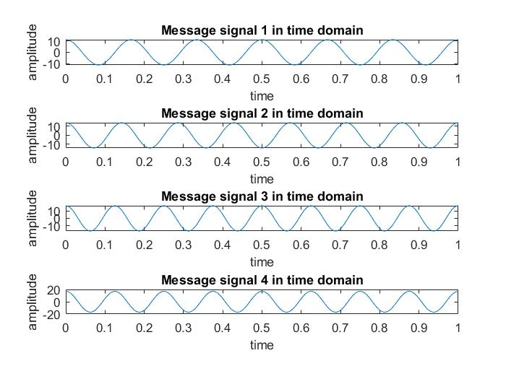

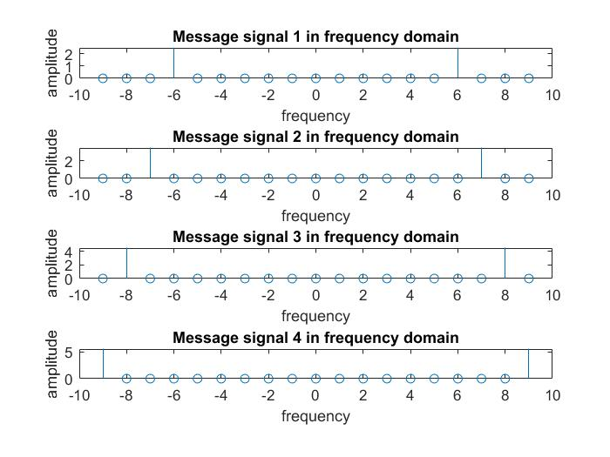

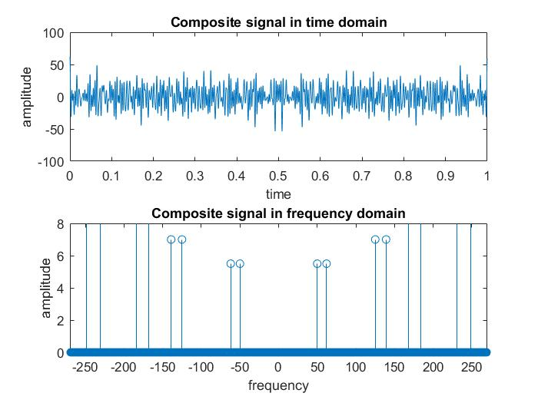

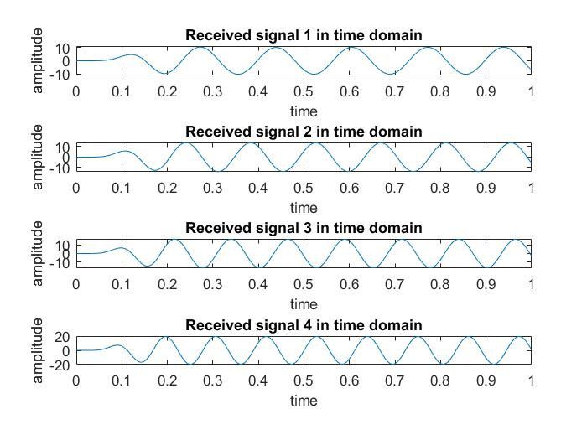

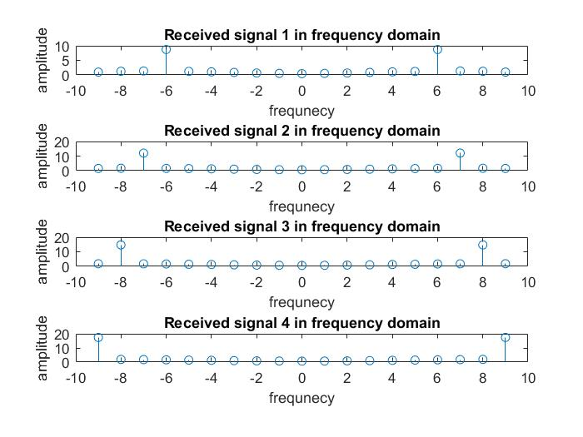

**Discussion:**

There is some of the bugs concluded with the definite organizational complementation with the functions of the MATLAB. The regression of the functions originated from the libraries inclines the comprehensive objective of this complementation. I face some problems while creating the plot and also face problems while calculation using my student id number. MATLAB takes some time while I try to run because my laptop configuration is low.